Name: Muzammil Ahmed

FA22-BSE-038

Topic: Todo App(Add task)

To

Sir Mukhtair Zamin

**Use Case Diagram:**

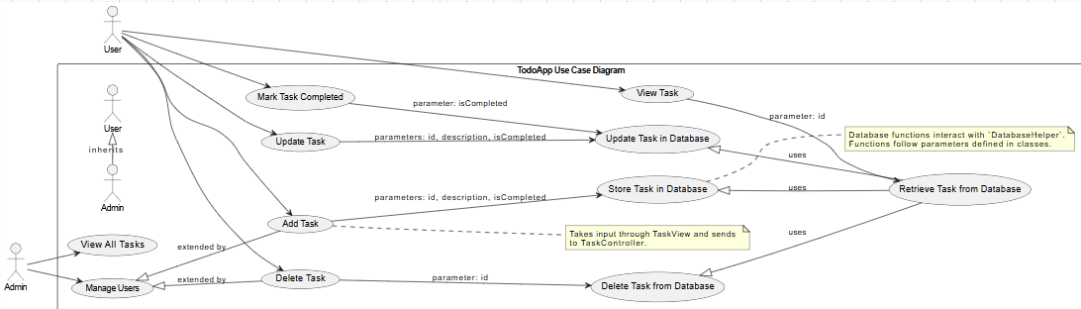

**Fully dress USECASE Diagram(View News):**

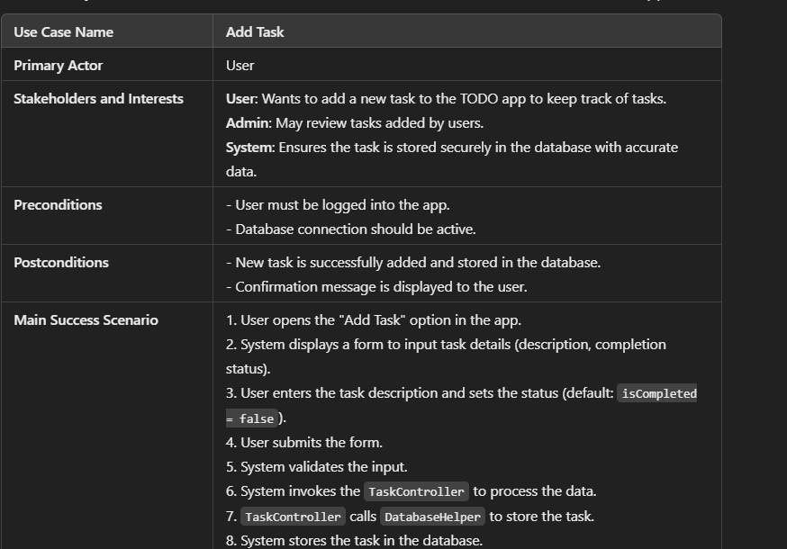

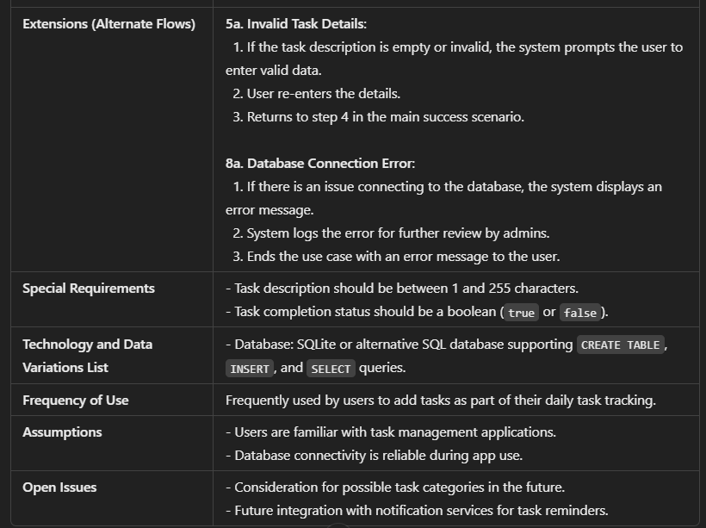

**Class Diagram:**

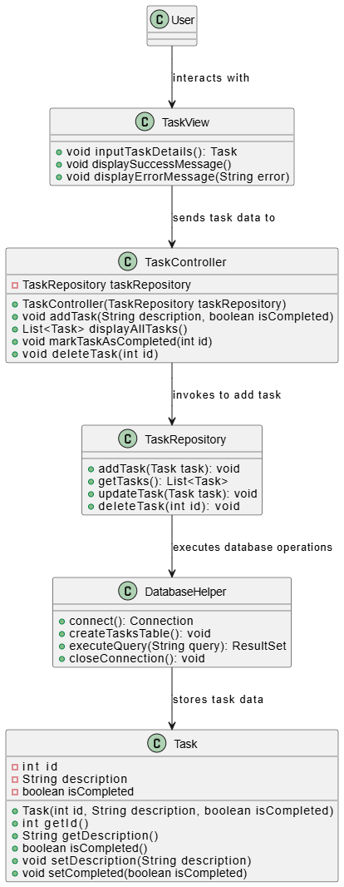

**Composition Diagram:**

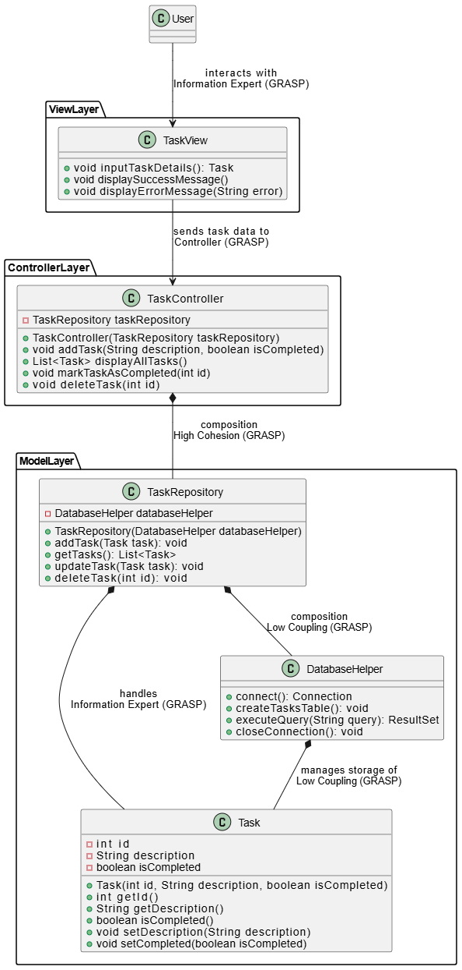

**System Sequence Diagram:**

